**PRACTICAL-9**

**AIM : Write a lex program to count the number of comment in the given c program. Also eliminate the comment and copy it in separate file.**

**CODE** :

**//comment.l**

%{#include<stdio.h>

int com=0;

%}

%s COMMENT

%%

"/*" {BEGIN COMMENT;}

<COMMENT>"*/" {BEGIN 0;com++;}

<COMMENT>\n {com++;}

<COMMENT>. {;}

\/\/.* {; com++;}

.|\n {fprintf(yyout,"%s",yytext);}

%%

void main(int argc, char *argv[])

{

if(argc!=3)

{

printf("usage : ./a.out in.txt out.txt\n");

exit(0);

}

yyin=fopen(argv[1],"r");

yyout=fopen(argv[2],"w");

yylex();

printf("\n number of comments are = %d\n",com);

}

int yywrap()

{

return 1;

}

**//in.txt**

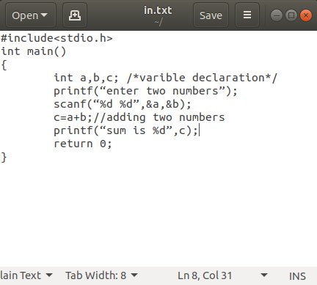

**OUTPUT :**

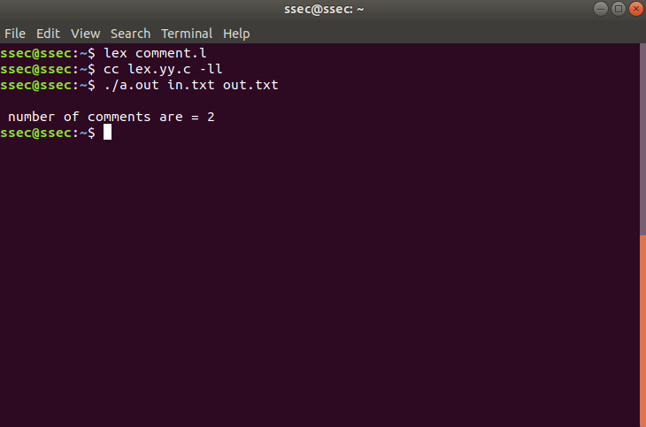

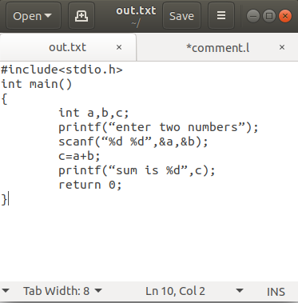**//out.txt**